**Program execution pipe line:**

1. Splash Screen. (Shows only on first build).
2. Sign-Up, Sign-In Screen. (Shows only when the user hasn’t saved any login data).
3. Home Screen.
4. Rooms.

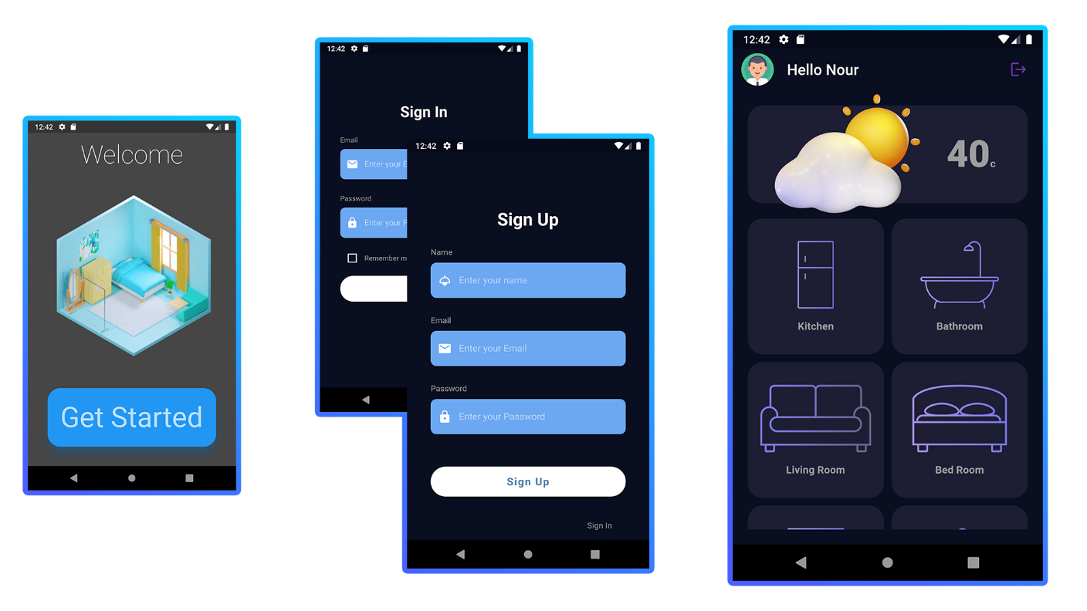

**Splash Screen:**

* It’s a screen that shows up for the user at the first open of the application.

**Authentication Screens:**

1. Sign-In: Shows for the user email and password input boxes where the user should fill them with his/her information.
2. Sign-Up: If the user doesn’t have an account already, he/she can fill up a form with their name, email and password, and then sign in.

**Home Screen:**

1. Shows up the user information up top.
2. Shows the temperature inside the house.
3. Show the rooms available for the user to navigate and control.

By pressing on any one of those rooms, the user will be directed to the screen of this room.